Objectives

- Configure switches and their ports for networking.
- Create a word DOC file – LAB3A-yourlastname.DOCX
- Format the headers per the SUBMISSION GUIDELINES in our iLearn resources
- Include the following sections in your lab submission
  - Purpose - In your own words, what is the purpose of this lab?
  - Questions – What are the answers to any questions asked in the lab?
  - New Terms/Commands – What new CLI commands or networking terms were introduced?
  - Comments/Reflection
A - Create the Topology
- Launch Packet Tracer on your workstation.
- Add a NOTE with your name, class id and the text “LAB3A Switch Configurations”
- Set Preferences to Buffer Filtered Events Only.
- Create the below topology:
  - Note that the second switch is PT-EMPTY device.
  - Change display name of switches to “YOURLASTNAME-1” and “yourlastname-2”
  - Configure PC’s to IPv4 192.168.10.# where # is the PC number (1-6)
  - Connect PC’s 1-4 to the switch’s ports 1-4.
  - Connect the switches via a crossover cable. Note – you will have to add GIGABIT-ETHERENET port modules to switch2
  - Connect PC6 and PC7 to switch 2.
  - Click on the FORWARD icon and ensure full connectivity.

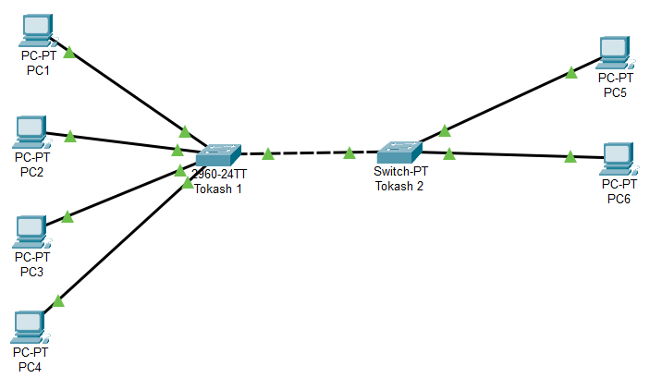
B – Configure Switch 1
- Add a console PC to Switch 1.
- The “Message of the Day” is generally used to post a legal warning to hackers. User the BANNER command to set a detailed warning message.
- Password protect the switch using ‘SECRET’ enable command. The password should be set to cisco.
- Enter exit to return to the initial mode, then go into enable mode. Did you see the message and were prompted for the password? If not, debug and fix.
- Change the descriptions of ports 1 through 3 to “Office PC”
- Change the description of ports 4 through 13 to “Warehouse PC”
- Shutdown all ports not assigned as either an office or the warehouse. Hint: use the “INTERFACE RANGE” command
- Change the duplex mode of ports 5-12 to half duplex
- Change the speed mode of all ports currently not connected to 10 Mbps
- Configure G0/1 to trunk mode with the switchport command
- Make the current configuration the configuration that the switch will be initialized to at start up.
C – Configure Switch 2
- Shutdown the port connected to PC6. Note: The port naming convention may be unique as we added modules to the device.
- Configure Gigaethernet port to trunk mode with the switchport command

Assignment Submissions

- Save the PKT file as L03a-yourlastname.PKT
- Complete the sections in the submission document. There are no screenshots but answer the following Questions:
  - What does the NO command do?
  - How do you configure multiple interfaces with one command?
  - What is the difference between an access line and a trunk line?
  - What are half-duplex and full duplex modes? And what device(s) can only run in half-duplex mode?
  - What is the difference between “enable password cisco” and “enable secret cisco”?
- Submit both the DOC file and the PKT file in iLearn.

- End of Lab -

